Coronavirus (COVID-19) test at home

To keep your family, friends and community safe take the coronavirus (COVID-19) test – with or without symptoms.
You can now perform your own coronavirus (COVID-19) test, in your own home. The test is for people 16 years and above.

This pack includes:
- Registration form
- Instructions for the self-collect coronavirus (COVID-19) test
- Coronavirus (COVID-19) test kit: swab, tongue depressor, specimen bag
Follow the instructions to take your own coronavirus (COVID-19) test at home.

How will my test be collected?
Store your coronavirus (COVID-19) test specimen in the bag provided.
You can either hand your completed test back to a community tester or call 1300 13 44 88 between 11am and 7pm and provide the following information: Name, address, contact number, number of kits to be collected and collection location.
If you require more testing kits to be delivered to your home, please call 1300 13 44 88 providing your address and the number of kits required.

How and when will I receive my test result?
Your test result will be sent via text message to the number you provide, this may take up to four days.
If you are still waiting for a result after five days please contact the coronavirus hotline on 1800 675 398.

Do I have to stay at home while I wait for my test result?
If you have symptoms and been tested for coronavirus (COVID-19), you need to stay at home until you receive your results.
Symptoms of coronavirus (COVID-19) are fever, cough, sore throat, runny nose, chills or sweats, shortness of breath, loss of sense of smell or taste.
If you do not have any symptoms, you do not need to stay at home until you receive your test result.

Remember to keep your distance – no handshakes, hugs or kisses.
Maintain good hygiene.

To find out more information about coronavirus and how to stay safe visit www.dhhs.vic.gov.au/coronavirus .
If you need an interpreter, call TIS National on 131 450.

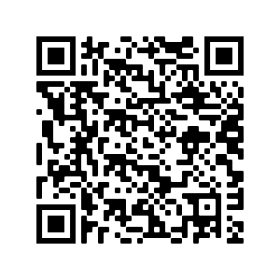For information in other languages

